

Unit 3 ATAR Human Biology

DENMARK SENIOR HIGH SCHOOL

Test 3: The Immune system

|  |  |
| --- | --- |
| Section | Marks available |
| A  Multiple Choice | 10 |
| B  Short Answer | 45 |
| C  Extended Answer | 20 |
|  | 75 |

Section A: Multiple Choice

1. The concentration of the mumps antibodies in the blood of a person was measured over a period of 90 days. The results are shown on the graph below.

0 30 6 90

Time (days)

**A**

Is it reasonable to conclude that the graph represents the concentration of the mumps antibodies in

1. A newborn baby whose mother had been vaccinated against mumps.
2. A newborn baby whose mother had a mumps antibody injection before becoming pregnant.
3. An adult who become infected with mumps at time A on the graph.
4. A child who had been vaccinated against mumps at time A on the graph

2. T lymphocytes (T cells) are responsible for

1. Producing antibodies
2. Attach themselves to disease causing organism and destroy them
3. Producing an allergic response
4. Agglutination of antigens.

3. The table below lists the causative agents for four different diseases:

|  |  |
| --- | --- |
| *Disease name* | *Causative agent* |
| Ebola | Virus |
| Creutzfeldt-Jacob Disease | Prion |
| Tinea | Fungus |
| Food poisoning | Bacterium |

For which of these diseases would treatment with antibiotics be most appropriate?

1. Ebola
2. Creutzfeldt Jacob disease
3. Ringworm
4. Food poisoning

4. Jack cut his foot on a piece of rusty metal and had to go to the doctor to have stitches.

The doctor also gave him an injection to prevent him from contracting tetanus.

The immunity that Jack gained from having the injection was

(a) passive and artificially acquired.

(b) passive and naturally acquired.

(c) active and naturally acquired.

(d) active and artificially acquired.

5. Which of the following blood components have a role in protecting the body from disease

causing micro-organisms?

(a) red blood cells and platelets

(b) plasma and platelets

(c) red blood cells and plasma

(d) white blood cells and platelets

6. Which of the following is an example of passive natural immunity?

(a) The body manufactures antibodies in response to an invading pathogen.

(b) Antibodies enter the blood stream via an injection of antitoxin.

(c) Antibodies enter the blood stream from mother to foetus across the placenta.

(d) The body manufactures antibodies after an injection of toxoids.

7. Which of the following differentiates correctly between antibiotics and vaccines?

(a) Antibiotics provide long-lasting immunity due to the production of memory cells,

while vaccines only provide short-term immunity.

(b) Antibiotics treat for an invading pathogen, while many vaccines involve the

introduction of an inactivated pathogen into the bloodstream.

(c) Antibiotics provide artificial, active immunity, while vaccines provide artificial,

passive immunity.

(d) Antibiotics are often injected into the bloodstream, while vaccines are normally

ingested in pill form.

8. Antivirals are medications that

(a) inhibit the development of viruses.

(b) destroy all pathogens.

(c) inhibit fungal and bacterial growth.

(d) kill viruses.

9. Which of the following contains a list of organisms that are only transmitted by viruses

(a) anthrax, common cold, Chlamydia

(b) ringworm, thrush, malaria

(c) AIDS, flu, chickenpox

(d) meningitis, tuberculosis

10. The following pathogen contains a cell wall, slime layer, cell membrane, capsule, DNA that is not bound by a nucleus and a flagellum. What is the pathogen?

(a) a virus

(b) a fungus

(c) a bacterium

(d) a protozoan

Section B:Short Answer

(45 marks)

Question 31 (11 marks)

The following question refers to the diagram shown below, which represents some of the

external defences to infection of the human body.

(a) In each box, explain how the structure indicated provides protection from infection.

(6 marks)

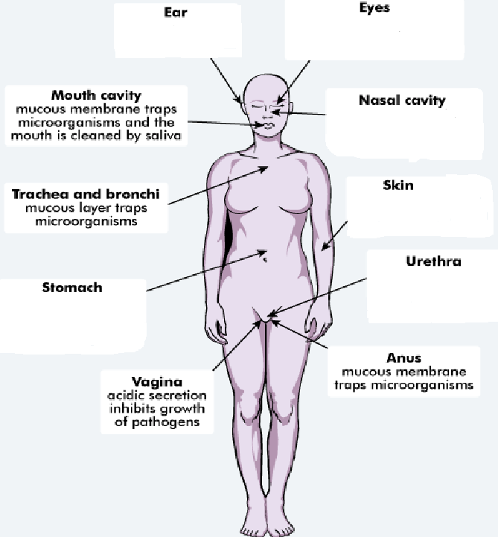

(b) An important strategy to reduce spread of infection is good personal hygiene.

List two strategies a person should follow to ensure good personal hygiene. (2 marks)

One:__________________________________________________________________________________________________________________________________________________________________________________________________________

Two:___________________________________________________________________________________________________________________________________________________________________________________________________________

(c) Inflammation is often a response displayed by the body when a pathogen has entered it.

Complete the table below, describing the action of each listed substance in the

inflammatory response. (3 marks)

|  |  |
| --- | --- |
|  | **Role in Inflammatory Response** |
| Heparin |  |
| Histamine |  |
| Phagocytes |  |

Question 31 (10 marks)

(a) Immunity can be classed as passive or active and natural or artificial. Complete the table

below, describing the different types of immunity. (4 marks)

|  |  |  |
| --- | --- | --- |
|  | Passive | Active |
| Natural |  |  |
| Artificial |  |  |

(b) The diagram below shows one of the actions of antibodies on pathogens.

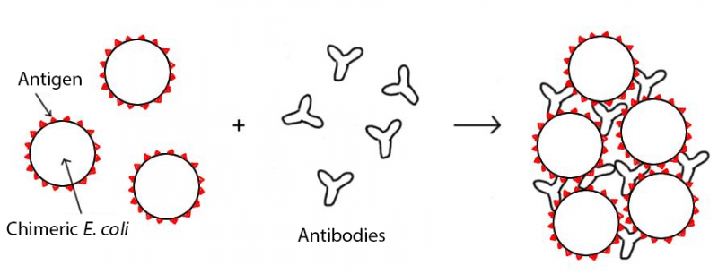

1. What action of antibodies does the diagram represent? (1 mark)

______________________________________________________________________________________________________________

(ii) Describe three other ways in which antibodies can act on pathogens to help fight

infection. (3 marks)

One:_____________________________________________________________________________________________________________________________________________________________________________________________________

Two:______________________________________________________________________________________________________________________________________________________________________________________________________

Three:____________________________________________________________________________________________________________________________________________________________________________________________________

(iii) Name the type of lymphocyte responsible for the production of antibodies.

________________________________________________________________________________________________(1 mark)

(c) Vaccines are considered a safe and reliable way of increasing the immunity of

populations. However, there are risks associated with vaccines.

Identify one risk associated with the production or use of vaccines.

___________________________________________________________________________________________________________ (1 mark)

Section C: Choose **ONE** of the two extended answer questions and write a response on the paper provided

Question 16. (20 marks)

1. John was not immunised against whooping cough when he was an infant. As a teenager he was exposed to the pathogen that caused the disease and became ill. Jennifer was vaccinated as an infant and when exposed as a teenager she did not contract the disease and showed only very minor symptoms.
2. Describe the processes that occurred in Jennifer’s immune system at the time of vaccination. (15 marks)
3. Explain the difference between Jennifer’s response and John’s response when they were exposed as teenagers to the pathogen (5 marks)

Question 17. (20 marks)

1. Multiple drug resistant bacteria are becoming a problem in treating some bacterial infections. Bacteria that have evolved resistance to antibiotics cannot be controlled or treated

Researchers have suggested that the overuse of antibiotics in the community has caused the evolution of generations of multiple drug resistant bacteria. Explain how this resistance would occur if three antibiotics, A, B and C were used in sequence to treat a bacterial infection. (10 marks)

1. Antibiotics can be used to treat bacterial infections but are generally not effective against viral infections
2. Outline the reasons why antibiotics are ineffective against viral infections (3 marks)
3. Describe **two (2)** other methods that can be used effectively against viral infections. (7 marks)